It Happened In Plain Sight
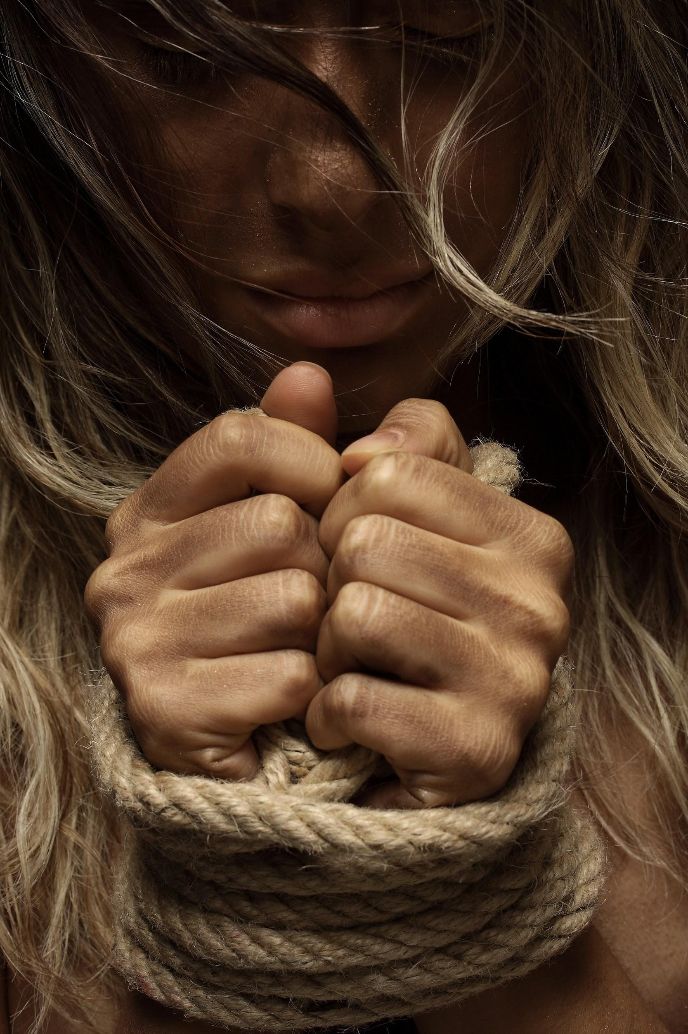

a feature length documentary proposal

It Happened In Plain Sight
Table of Contents:
- Introduction 2

- Concept 2

- Story 3

- Cast Biographies 7

- Status of Film 8

- Comparative Analysis 8

- Contact Information 9

It Happened In Plain Sight
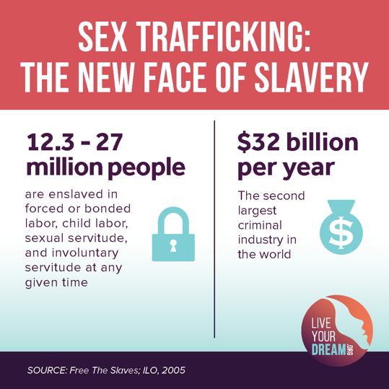
- Introduction
Set in three modern third world countries, It Happened In Plain Sight is a feature length documentary following three stories told by women who lived in the heart of the sex trafficking world. They’re survivors, and these are their stories. By combining their stories with shocking statistics of the new age of sex trafficking, It Happened In Plain Sight will bring attention back, in an unique fashion, to a topic many audiences are over looking.
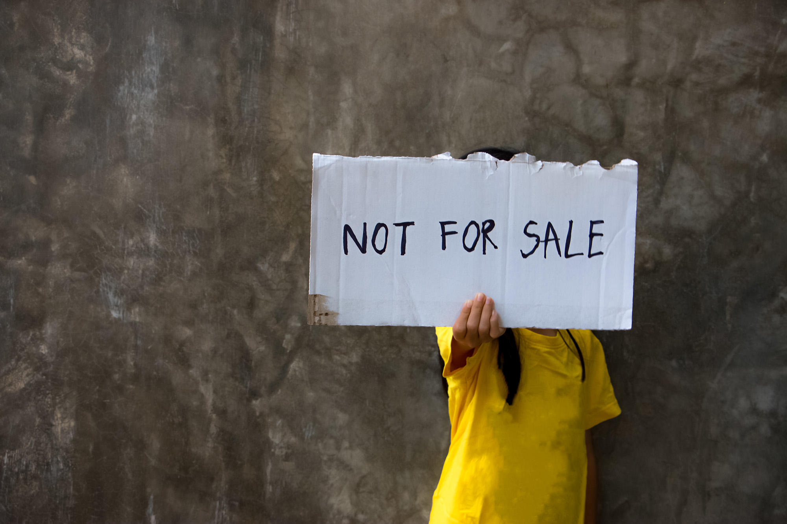

- Concept

 | Overview
Genre | Dramatic Real Word Thriller
Production | 16mm shot in studio with reenactments of their lives in Dubai, China, and Mexico City
Distribution | Intended for a platform release for at least 45 markets
Marketability | Name talent & executive producer; music soundtrack tie-in, realism
Budget | Available upon request

The story follows Luiza Karimova, Khawng Nu, and Karla Jacinto as they are interviewed about their early childhood into their lives in the sex trafficking world. They each describe their humble beginnings as children, so innocent and pure. Reflecting on the complexity and horror of their lives, they describe in gruesome detail what they experienced in their teenage years. The heartache and loneliness that comes with being sexually abused and forced to sell their bodies becomes very apparent. Luiza left her home to find work but found it difficult to find employment. A woman offered her a job as a waitress, but it turned out to be something much more sinister than just waiting tables, she becomes a sex slave. Khawng was offered a similar job at a factory, and soon realized she had been deceived. She had been trafficked to birth babies. Karla was convinced at 12, by a “sweet innocent man” she had met to go on a trip with her. From that moment on she was sold and believes she was raped over 43,000 times. While we follow their stories, we are given staggering facts and data about the amount of sex trafficking that happens every day all over the world. The documentary will open a gateway into how relevant this horror is. While each woman talks and discusses her story there will be cuts to reenactments of her horrors, creating 3 small films in one, each ending together. In the end each woman, real time, attends a convention with UN Women, and organization promoting gender equality, and the empowerment of women. They each want to focus on gaining more resources and help for girls who are experiencing similar stories of their own in the cities they were abused in.
The genre of this documentary is dramatic real-world thriller. By combining the interviews with reenactments from actresses the audience becomes much more involved and interested as well as gives an idea on how traumatic the events were.

- Story
ACT 1:
The story begins with Luiza Karimova describing her life as a child in Uzbekistan. She lived a humble small life on the outside landscapes of the city. She is quite pretty and intelligent, one of those girls who looks younger than she is. Because of her lower class status, she was unable to continue to higher education while growing up. Besides this she experienced a good beginning to her life, she was well taken care of and had a close relationship with her mom. Luiza describes and tells some of her favorite stories as a child, including how she used to go to Sunday markets every week and her mother let her pick out any dessert she wanted.
We reopen with Khawng Nu who sits down and describes her childhood while living in Kachin, an impoverished state in northern Myanmar. This was a very small village she explains, everyone knew everyone. Growing up was a struggle but equally rewarding. She explains how she always felt so at peace and close with her village. As she grew up she realized how little jobs there were for the people of the town. As a child she spent her days playing in the river, not thinking about where her life was going or how she was going to get on with making a life for herself. As she describes these stories there in guilt and pain in her eyes.
Finally, the last character is revealed Karla Jacinto, born and raised in Mexico City. Unlike the other two Karla didn’t have a good upbringing. She describes her childhood as harsh and abusive. She found pleasure in the little things, and always wanted to be outside, to feel the sunshine on her face. She describes not remembering much of her early years, except not feeling welcome. She then describes her life at age 12. When she is targeted by a much older man who lures her out of her depression by offering her kindness and candy. He begins to talk to Karla and tells her that he too was abused as a child. She says she felt safe with him, like he understood her. They began to spend a lot of time together, she always left her house early and wouldn’t come home till late because they would go and talk in a park or somewhere, he bought her clothes, shoes flowers, chocolate, and showered her with attention. This man, who was 22, became Karla’s safe haven. There was no doubt in her mind when he asks her to come away with him. She becomes uncomfortable when telling this part of the story. An uneasy feeling overwhelms her.
ACT 2:
In this second act, all of the woman’s childhood lives make a dramatic switch. They dive deep into their stories on how they were sex trafficked. Luiza Karimova once again starts first and begins telling her story. At 22 years old, Luiza left her home in Uzbekistan, in hopes of finding work. She ended up traveling to Osh, Kyrgyzstan. Without a Kyrgyz ID or a university degree showing higher education, Luiza found it very difficult to find work. She was struggling and needed money so when a woman offered her a waitressing job in Bishkek she gladly accepted.
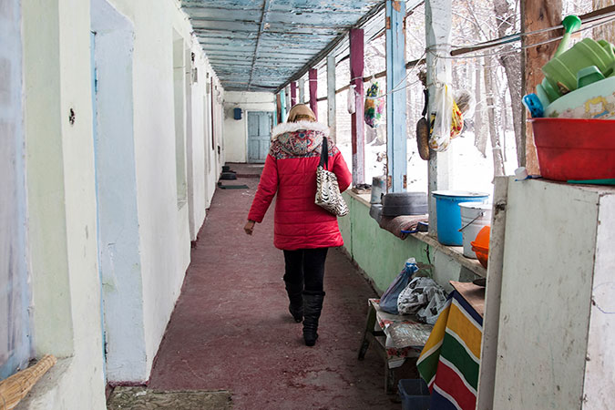
After arriving in Bishkek and following the instructions the woman had given her, she ended up at an apartment where instead of getting details about her new job she recalls they “They held us in an apartment and took away our passports. They told us that we’d be photographed again for our new employment documents, to be registered as waitresses. It felt strange, but we believed them.” She was then suddenly put on a plane to Dubai where there were brought to another apartment and handed fake passports. “We were to be sex slaves and do whatever the clients wanted. The next day I was sent to a nightclub and told that I would have to earn at least 10,000 USD by the end of the month,” says Luiza. For the next 18 months her life was consumed with nightclub work where she was constantly abused. She discusses some of her more terrifying experiences, like when she refused a client one night and was shoved into a back alley and beaten until her eyes were swollen shut. She continues to tell equally as horrible stories and tells everyone that she obviously wants to get our but her self-esteem and trust was so low she couldn’t even bring herself to talk about it, let alone run. She also desperately needed the money.
While leaving the club one night, she sees a police officer approaching and instead of running she stays to let him catch her. She notes that “I was deported back to Osh, and since my ID was fake, I spent a year in jail. I filed a police report, and three of the traffickers were captured”. After she was released from prison, she was ashamed and in desperate need of some money; she went back to work in the sex industry because it was all she knew. She was later approached by Podruga a nonprofit organization that works with woman subjected to the sex trafficking industry and helps them find a way out. Now almost a year and a half later, Luiza works with Podruga to help women who find themselves in the exact same position she was in. She ends with “To stop trafficking of women and girls, we have to inform people about the full consequences of human trafficking and how to detect the signs. It is critical to start raising awareness about this in schools, starting young, so that they do not become victims.”

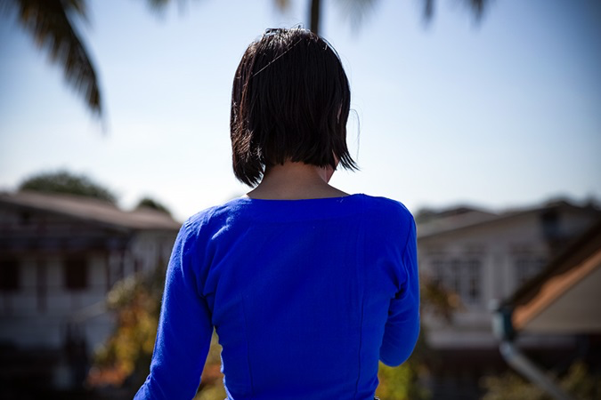
Khawng Nu then begins to tell her story. At the age of 22, she knew she needed to find work and her hometown wasn’t offering any. A woman from her village offered her factory work in China and she accepted right away, however when she got to China she learned her fate was something much more devastating. She had been trafficked to birth babies. She said they would force us to take pills and inject them with sperm in order to carry babies for Chinese men. She was told that when the baby was born she was supposedly receive 1 million MMK or 632 USD. She was told that if she resisted at all she would be beaten and if she ran she would be killed and her body wouldn't be returned to her family; returning a body to it’s family is a very important tradition in her culture. Khawng notes that she saw around 40 women on the floor of the building she was brought to in China, some as young as 16.

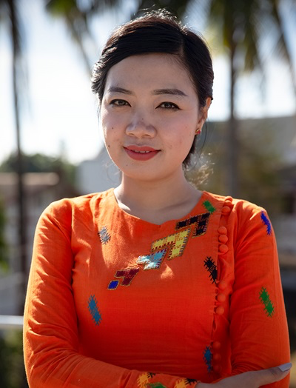
She was able to send out a message to her family, who then shared it with the pastor of the village who told local village leaders. The woman, or broker, who trafficked her was caught and arrested but didn’t give the location of Khawng. Eventually her family was able to pay ransom for her return. They had to borrow from neighbors to pay the 10 million MMK or a 6,230 USD. Khawng now talks to and works with Htoi Gender and Development Foundation, a partner with UN Women. “Now, after meeting with other women trafficking survivors through the peer group organized by Htoi, I no longer feel alone and seeing that there are other women who went through the same experience gave me courage” Khawng says.

Finally, Karla Jacinto talks about her experiences. At 10 years old Karla was convinced by an older gentleman, who had connected with her about being abused as a young child, to move in with him. Because her home life was not a good one, she decided to go with him. She notes that “I lived with him for three months during which he treated me very well. He loved me, he bought me clothes, gave me attention, bought me shoes, flowers, chocolates, everything was beautiful.” That is until he sat down with her one night and told her everything she had to do, “the positions, how much I need to charge, the things I had to do with the client and for how long, how I was to treat them and how I had to talk to them so that they would give me more money," Karla says. For the next four years, Karla would work as a prostitute. She describes many horrific memories of her time as a sex worker.
After the first week, it was decided she would see 30 different customers a day, 7 days a week, no holidays off, no sick days. She describes how she was beaten by her trafficker after a man had given her a hickey. "He started beating me with a chain in all of my body. He punched me with his fists, he kicked me, pulled my hair, spit at me in the face, and that day was when he also burned me with the iron. I told him I wanted to leave, and he was accusing me of falling in love with a customer. He told me I like being a whore” she says. The amount of not only physical, but mental abuse was draining. At 15 years old she got pregnant and had a baby of a pimp. He would use her baby girl to threaten her, saying that if she tried to leave or do anything, he would harm or kill the baby. Her baby was taken from her by the pimp and he told her she wouldn’t be able to see her again for over a year. During this time, Karla was rescued during an anti-traffic operation in Mexico City. She has now, at the age of 23 become an outspoken advocate against sex trafficking. She says "These minors are being abducted, lured, and yanked away from their families. Don't just listen to me. You need to learn about what happened to me and take the blindfold off your eyes."

ACT 3:
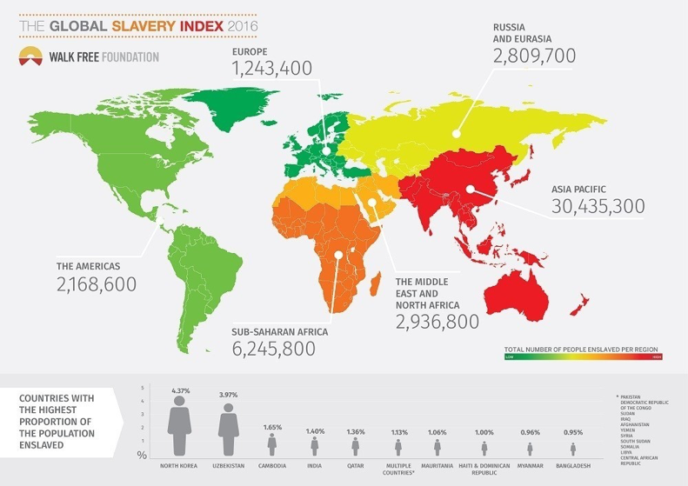
These three women will have complete closure as they attend a convention with UN Women, and organization promoting gender equality, and the empowerment of women. In real time they come face to face with organizations who work tremendously hard to stop the sex trafficking happening today. They will meet on March 9, 2020 in New York at the UN Commission on the Status of women. Here they will share their stories to a large audience and receive support. From here on, the woman's full-time job is with the Un Women traveling the world and telling their stories, hoping young girls will hear about them and find a way to get out of the sex trafficking happening right under our noses.

- Cast Biographies
The cast will be used in the reenactments of the scenes the women describe. To not take away from the women themselves, the cast chosen aren’t widely known. Just so the focus stays on the survivors. These are some ideas or actresses to play our survivors.

Luiza Karimova played by Bahar Soomekh:

Khawng Nu played by Rene Liu:

Karla Jacinto played by Gina Vargas:


- Status of Film
Currently this documentary is still in the research stage, however this is the biggest stage for this documentary, as the production and post-production editing will not take very long. It was more important to make sure the information was correct and add in as much about sex trafficking data as we can. Currently research should be done by Jan 2020, with production starting right after till about mid-February. We’ll then give post production till end of March 2020 to finish the documentary. Total budget/revenue for this film has come to around $10,000 for studio time and paying the crew and actresses. A lot of the film has been sponsored by UN Women.

- Comparative Analysis
Documentaries can do well but are usually slow growers and then suddenly catch on and break out in success. The films that follow, illustrate several genres that are similar to It Happened In Plain Sight with similar filming styles.

Title | Description | Year
Abducted In Plain Sight | In the early 70s, Jan Broberg is abducted by the least likely of people in her family's eyes: their neighbor. The film follows her stories, with many interviews by Jan Brobergs family members. | 2017
Blackfish | While following the traumatic story of Tilikum, a captive killer whale who has hurt and taken the lives of many trainers over the course of his life, there are underlying problems in what we know about these intelligent animals and the sea-park industry as a whole. | 2013
Fire In Paradise | What was at first seen as a small wildfire in Butte County, CA quickly gets out of control bringing massive amounts of devastation and death to a town known as Paradise. | 2019
Icarus | Filmmaker Bryan Fogel who wanted to uncover the truth about doping in sports, has the rare opportunity to meet with a Russian scientist who transforms his small film idea in a geopolitical thriller. He uncovers the biggest scandal in sports history. | 2017
The 13th | Following the history of racial inequality in the United States, filmmaker Ava DuVernay looks at the fact that most of the nations prisoners are African American. | 2016
Fyre | Fyre Festival was a luxury music festival created to promote the company’s Fyre app for booking music talent, created by Billy McFarland. It soon became very aware of the people who bought tickets and flew out that it was a complete fraud. | 2019

These films noted are of similar context to this documentary. They follow the same type of final pitch as well as the same interview/ reenactment pattern that this documentary does. It Happened In Plain Sight follows the stories of these women in an interview style composition, with reenactments by actresses to further the story.

- Contact Information
For more information, please contact:

Alexandria Ingvardsen
Chico State Productions
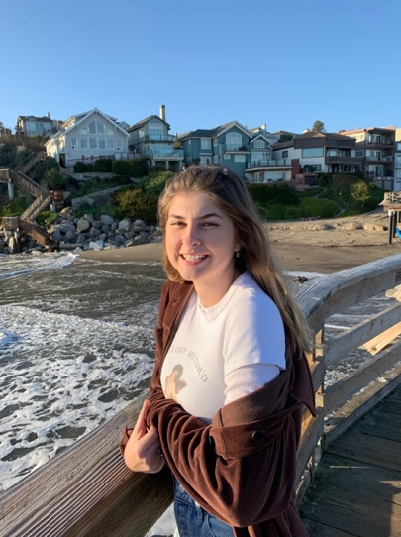
400 West First St
Chico, CA 95929
(408) 668-5423
aingvardsen @mail.csuchico.edu

Title: It Happened In Plain Sight

VIDEO | AUDIO
FADE IN TO BLACK SCREEN THAT READS: “IT HAPPENED IN PLAIN SIGHT” | SFX: Very soft and low piano music playing. There’s no particular tone to the song it’s just classic piano music.
- INT. -FILM STUDIO -DAY  MS OF LUIZA KARIMOVA SITTING ON A STOOL IN FRONT OF A VERY LIGHT BLUE BACKGROUND. YOU CAN TELL SHE’S SHORT EVEN WHEN SHE’S SITTING DOWN. SHE HAS DARK SKIN AND EVEN DARKER EYES.  SHE SMILES AND HER EYES LIGHT UP.  BEAT | LUIZA: “Hi, my name is Luiza Karimova. I’m 25 years old.”
- MS OF KHAWNG NU.  SHE’S SITTING IN THE SAME CHAIR LUIZA SAT IN. SHE’S ALSO TINY, BUT WITH VERY BROAD SHOULDERS. HER SHORT HAIR HIDES HER FACE SLIGHTLY.  SHE LOOKS UP AND GRINS.  BEAT | KHAWNG: “Hey, I’m Khawng. I’m 24.”  (soft spoken)
- MS OF KARLA JACINTO.  SITTING IN THE SAME CHAIR AS THE OTHERS. SHE’S TALL, WITH A SLENDER FACE AND LONG BROWN HAIR. SHE HAS A STERN FACE AND A SMALL NOSE.  SHE STARES DIRECTLY INTO THE CAMERA, NO FACIAL EXPRESSION AT ALL.  BEAT | KARLA: “I’m Karla Jacinto. I’m currently 23 years old.”
- A TRIPLE PROJECTED SPLIT SCREEN SHOWS LUIZA, KHAWNG, AND KARLA.  THEY LOOK AT THE SCREEN INTENSELY. THEY LOOK LIKE THEY HAVE A SECRET THEY’RE HIDING. EACH ONE LOOKS DOWN ONTO THEIR LAP. BOTH LUIZA AND KHAWNG START TO NERVOUSLY MESS WITH THEIR FINGERS.  THEY ALL LOOK BACK UP AT THE CAMERA.  CUT TO BLACK | SFX: Piano music cont.  SFX: Piano music stops suddenly.
- FADE IN FROM BLACK.  MONTAGE OF RECREATIONS OF LUIZA, KHAWNG AND KARLAS STORIES APPEAR ONE AFTER THE OTHER RAPIDLY. CAN’T MAKE OUT TRULY WHATS APPEARING. THERE’S A BLACK SCRATCHED LOOK LIKE THE SCENES ARE FROM A FEW YEARS AGO.  CU OF A MANS HAND HOLDING A YOUNG GIRLS HAND.  CUT TO LS OF INSIDE A SHIP CONTAINER LOOKING THING, THERE ARE YOUNG WOMAN EVERYWHERE.  CUT TO CU OF THE MANS HAND AGAIN, HE’S PULLING THE GIRLS HAND HARDER.  CUT TO MS OF MAN HANDING AN OLDER WOMAN MONEY. THE OLDER WOMAN POINTS TO MANY GIRLS BEHIND HER.  CUT TO CU OF A GIRLS FACE ON A PILLOW, A MANS HAND SMOOSHING HER CHEEK DOWN.  CUT TO MS OF A GIRL CRYING WITH HER HEAD DOWN IN BETWEEN HER LEGS.  CUT TO OS OF A GUN POINTED AT A GIRLS HEAD.  CUT TO MS A GIRL LOOKING DOWN IS HANDED CRUMPLED UP MONEY FROM A MAN OFF SCREEN  FADE OUT. | OS: (Young girls voice)  “But I don’t want to go there.”  SFX: Small unintelligible chatter amongst the woman.  OS: (mans voice) “Come on it’ll be fun!”  OLDER WOMAN: “Have your pick.”  SFX: Deep heavy breathing. The girl whimpers.  SFX: Soft cries  OS MAN: “Don’t look at me woman!”  OS MAN: “Take it.”
- MS LUIZA SITTING BACK ON THE STOOL. | OS: “So tell us about your childhood.”
- MS SIDE SHOT OF LUIZA. | LUIZA: “I grew up in Uzbekistan.”
- MS OF KHAWNG SITTING ON THE STOOL. | KHAWNG: “I’m from Myanmar.”
- MS SIDE SHOT OF KARLA | KARLA: “I grew up in Mexico City.”
10.SIDE SHOT OF LUIZA. | OS: “So tell us about your childhood.”
11.MS SHOT OF LUIZA LOOKING STRAIGHT INTO THE CAMERA LIKE SHE’S SEEN A GHOST.

